Database Ultimate notes

Most Important ER Diagram

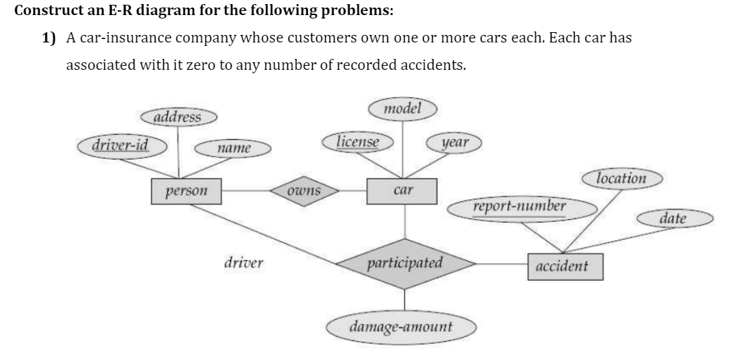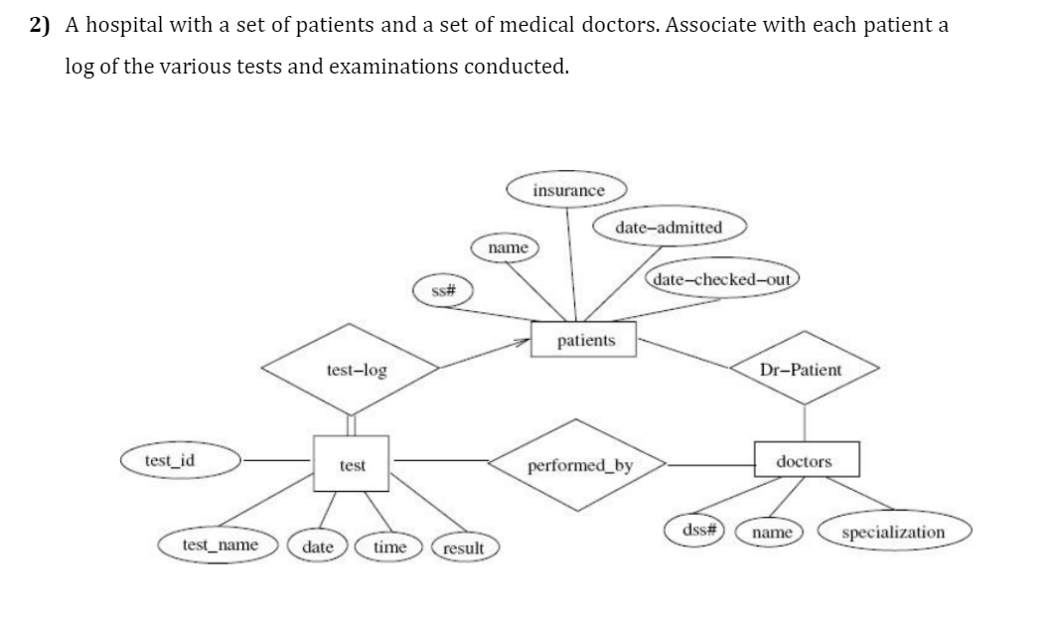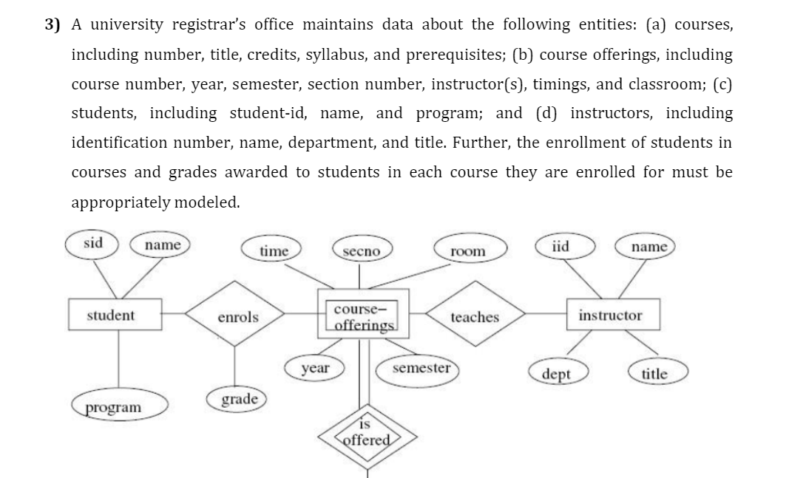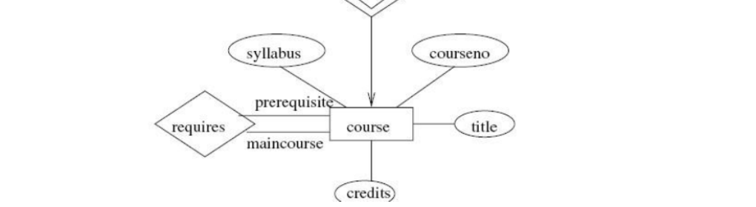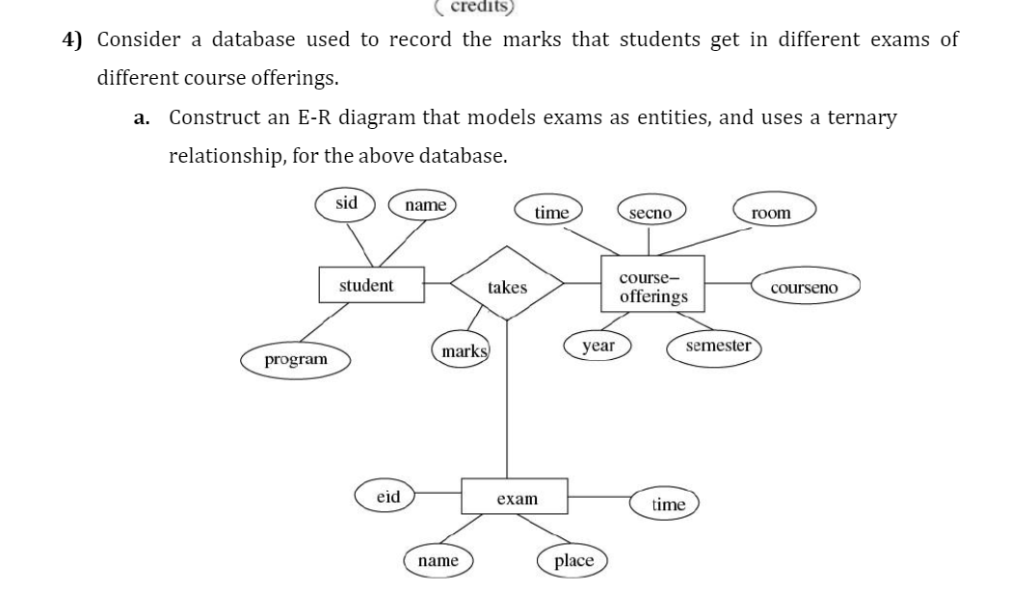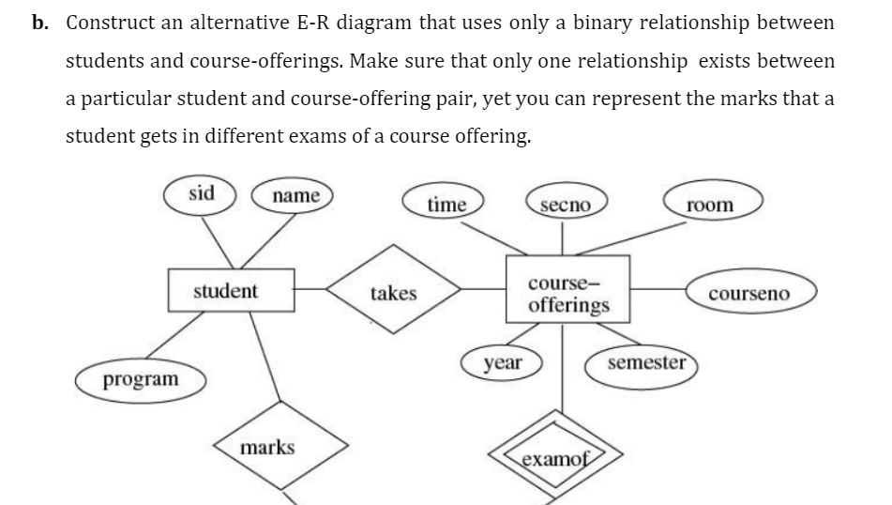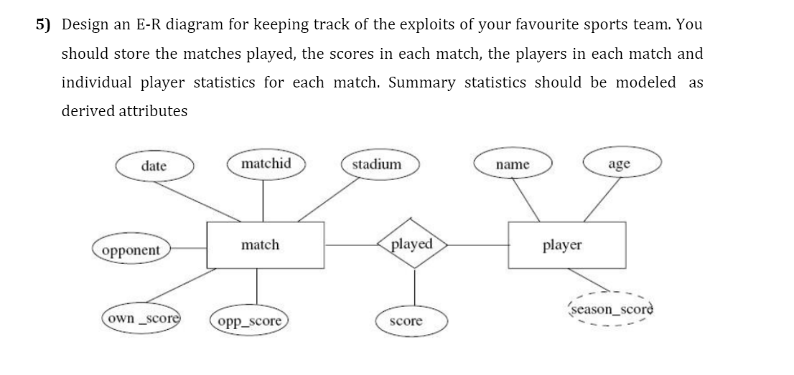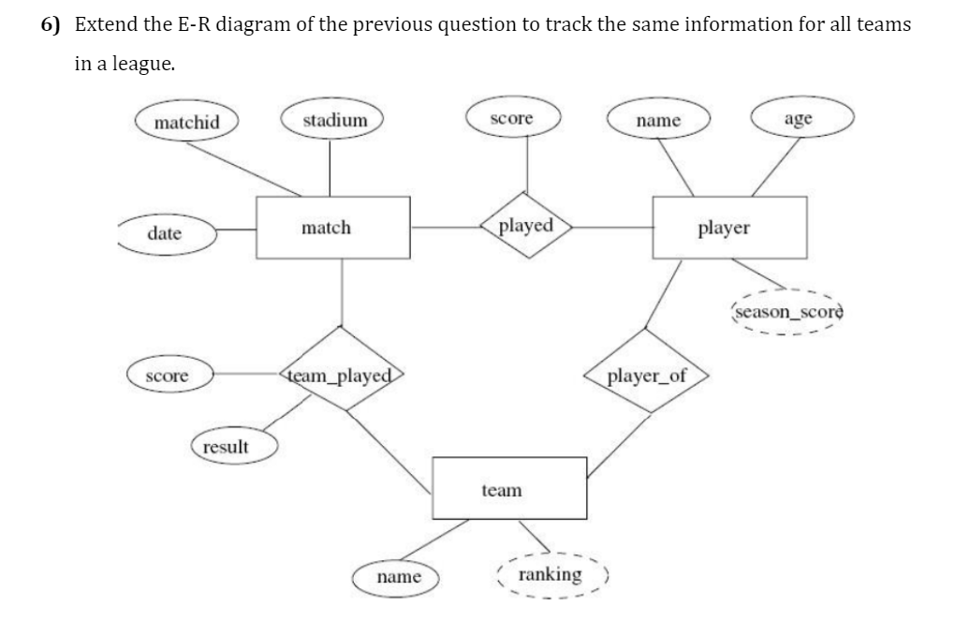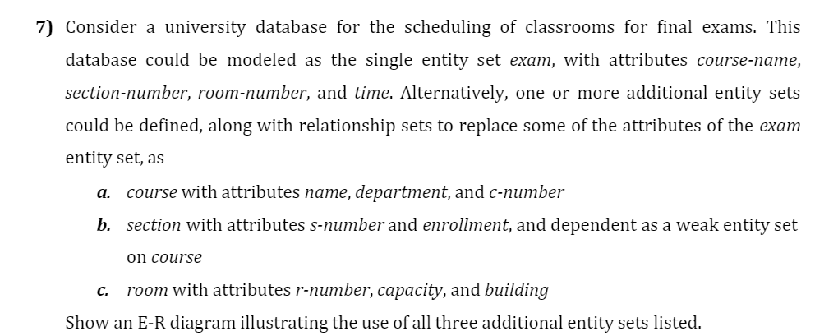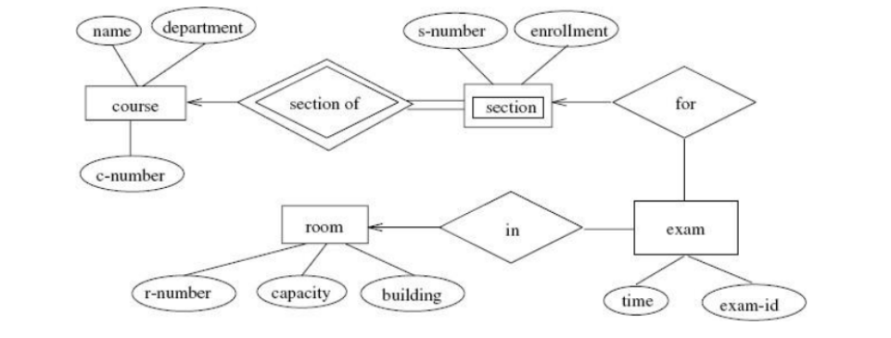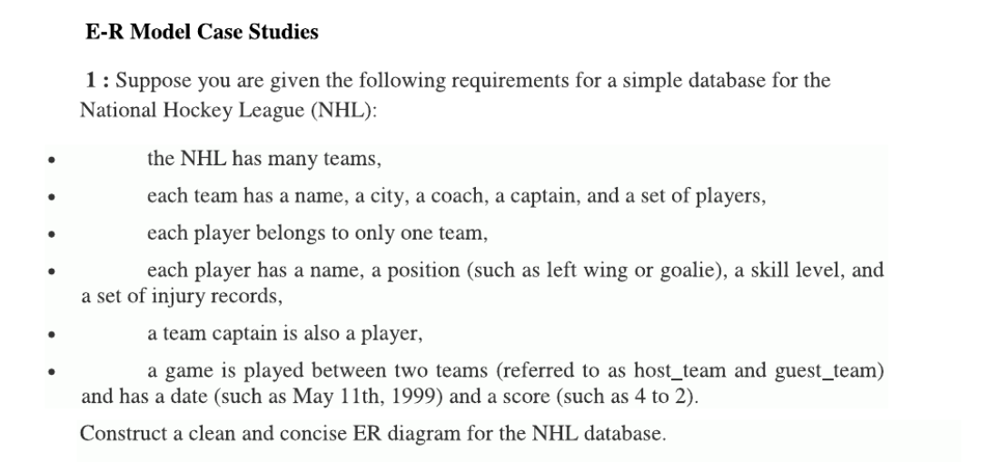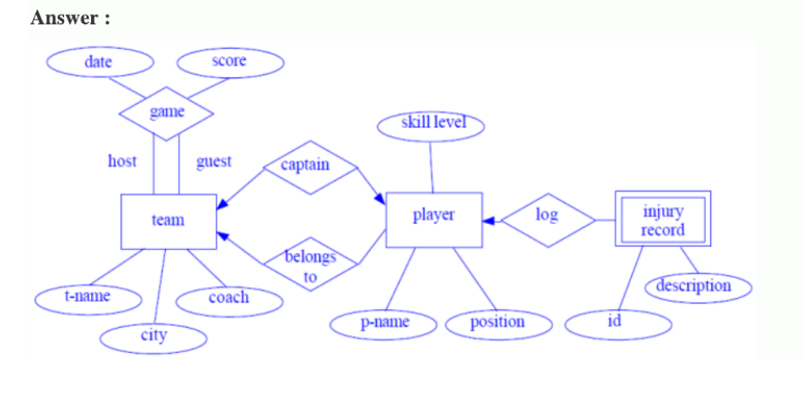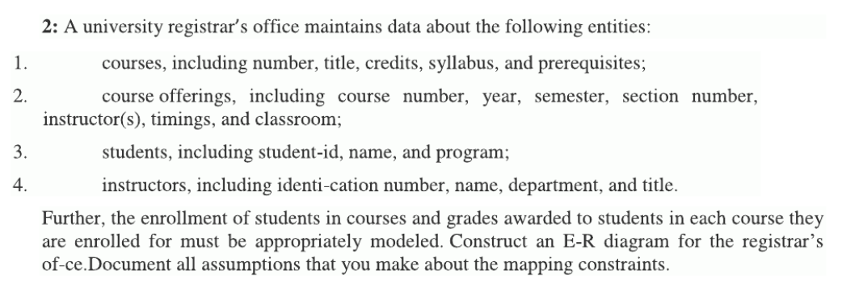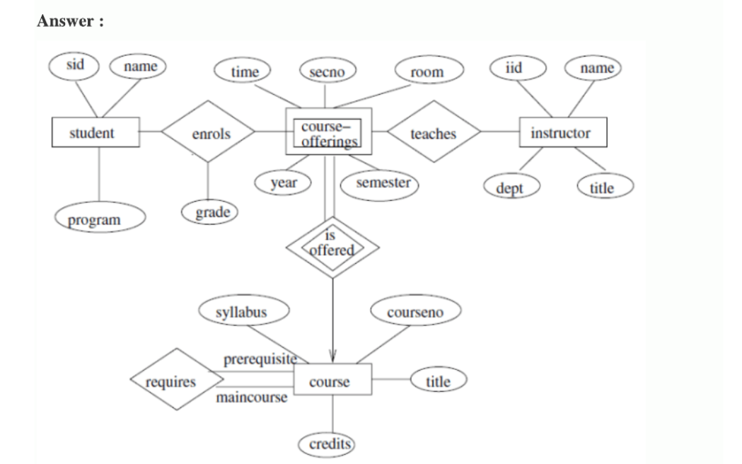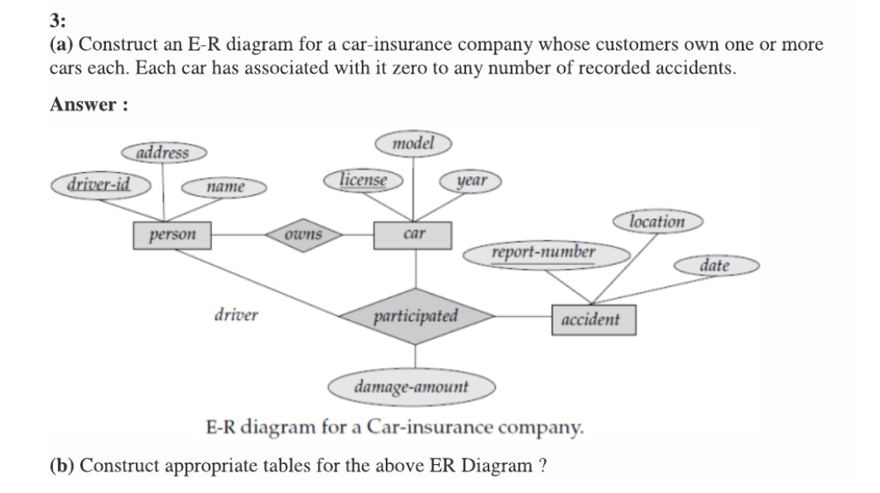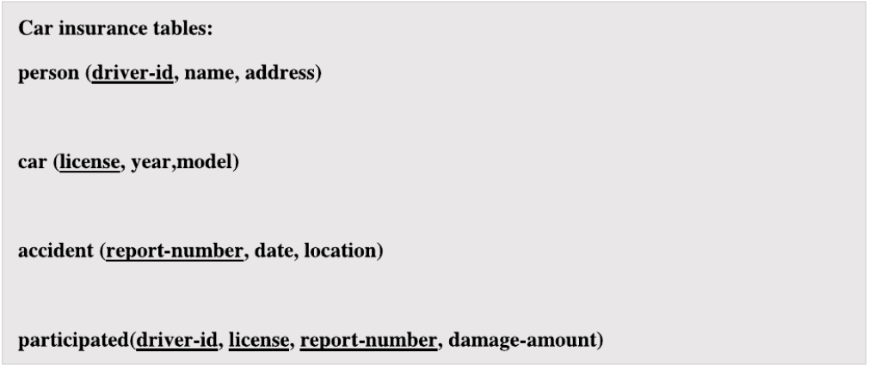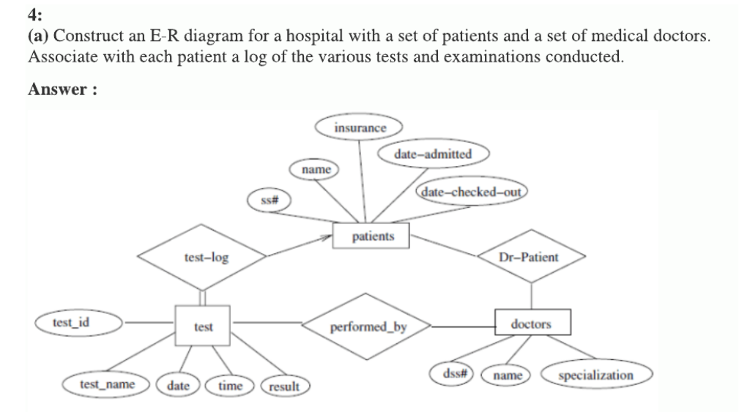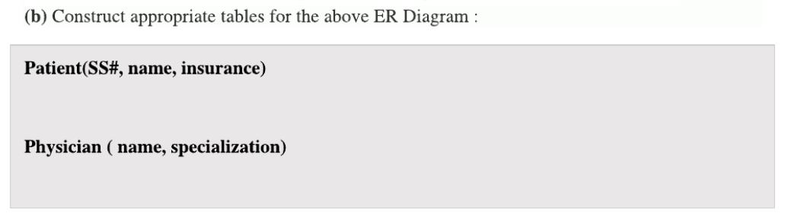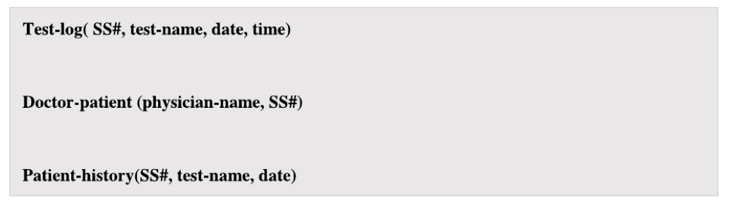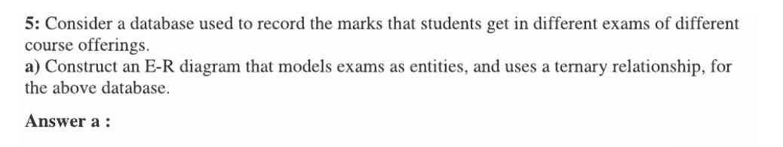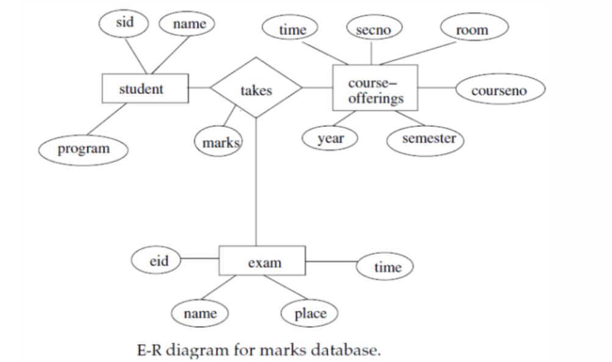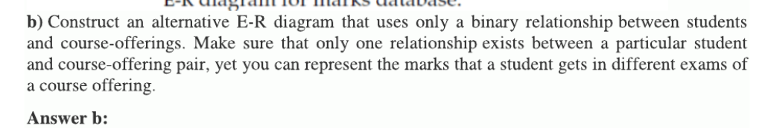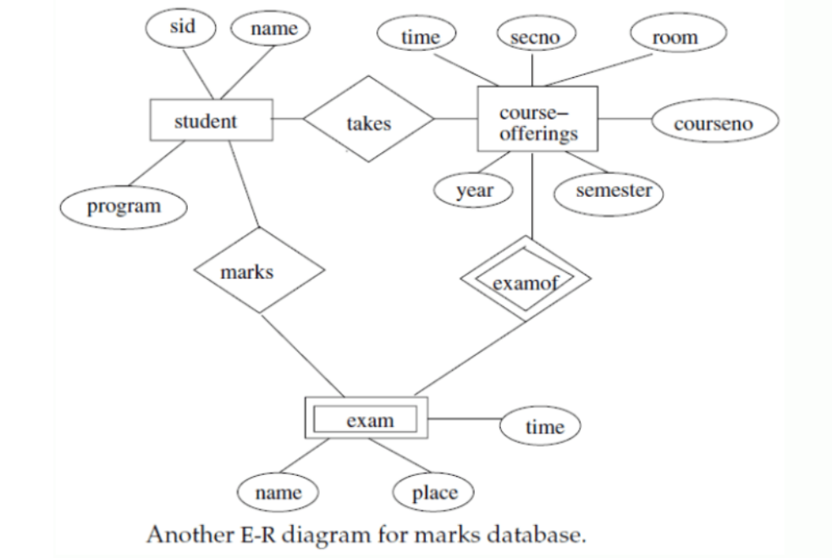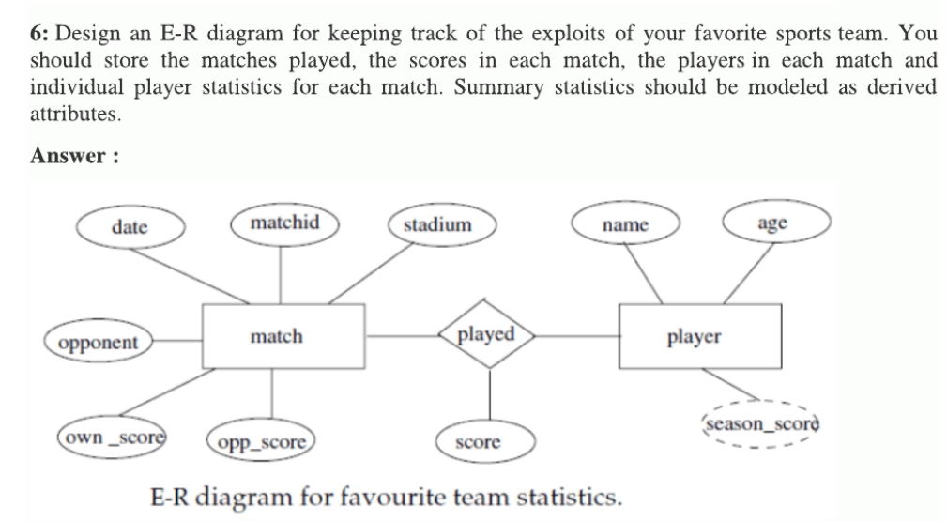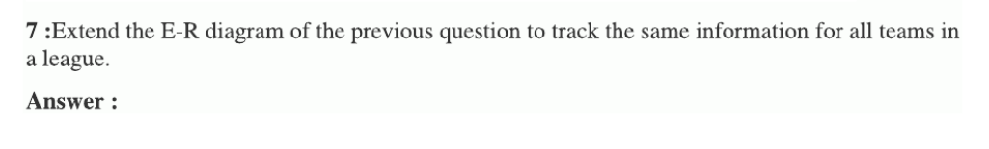

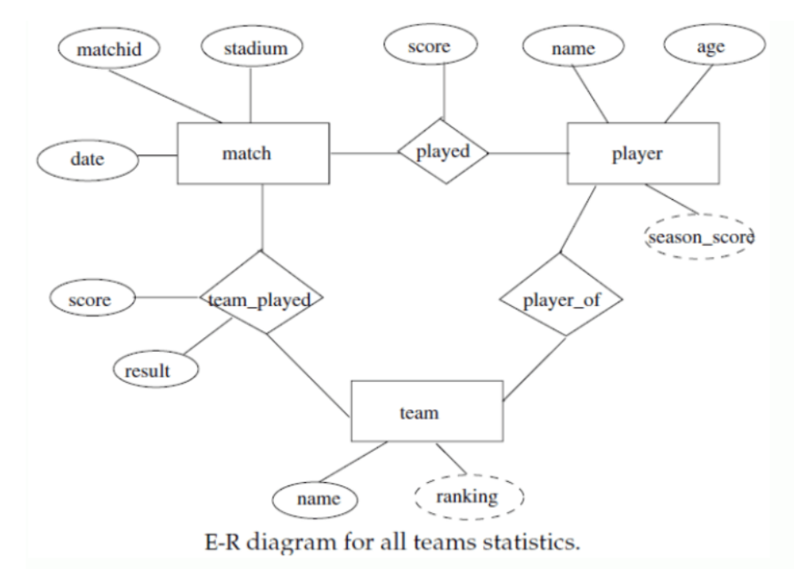

raw an ER diagram for the given scenario;

Suppose that you are designing a schema to record

information about reality shows on TV. Your database

needs to record the following information:

_ For each reality show, its name, genre, basic_info and

participants name. Any reality show has at least two or

more participants.

_ For each producer, the company name, company

country. A show is produced by exactly one producer. And

one producer produces exactly one show.

_ For each television, its name, start year, head office. A

television may broadcasts multiple shows. Each show is

broadcasted by exactly one television.

_ For each user, his/her username, password, and age. A

user may rate multiple shows, and a show may be rated

by multiple users. Each rating has a score of 0 to 10.

Draw an entity relationship diagram for this database.

Database Management System 4 (NCS-502)

Prepared By: Dr. S. K. Gaur RKGIT

6) Extend the E-R diagram of the previous question to track the same information for all teams

in a league.

7) Consider a university database for the scheduling of classrooms for final exams. This

database could be modeled as the single entity set exam, with attributes course-name,

section-number, room-number, and time. Alternatively, one or more additional entity sets

could be defined, along with relationship sets to replace some of the attributes of the exam

entity set, as

a. course with attributes name, department, and c-number

b. section with attributes s-number and enrollment, and dependent as a weak entity set

on course

c. room with attributes r-number, capacity, and building

Show an E-R diagram illustrating the use o